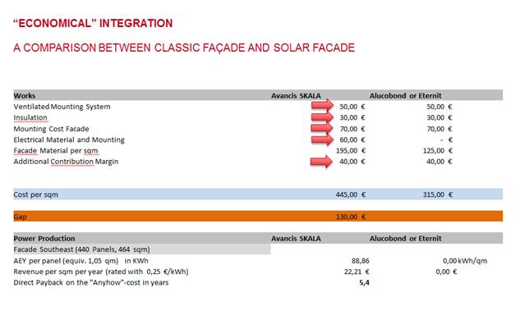

The payback time is meant for the gap of 130,-€/m²

* Energy yield for south façade      88,86 kWh/m² and year (to be changed for a location in SE)
* Price per kWh                                  0,25,-€/kWh                                    (to be changed for your situation)
* Means yearly revenues                 22,21 €
* Payback time 130/22,21 =            5,85 years

Kind regards

Norbert