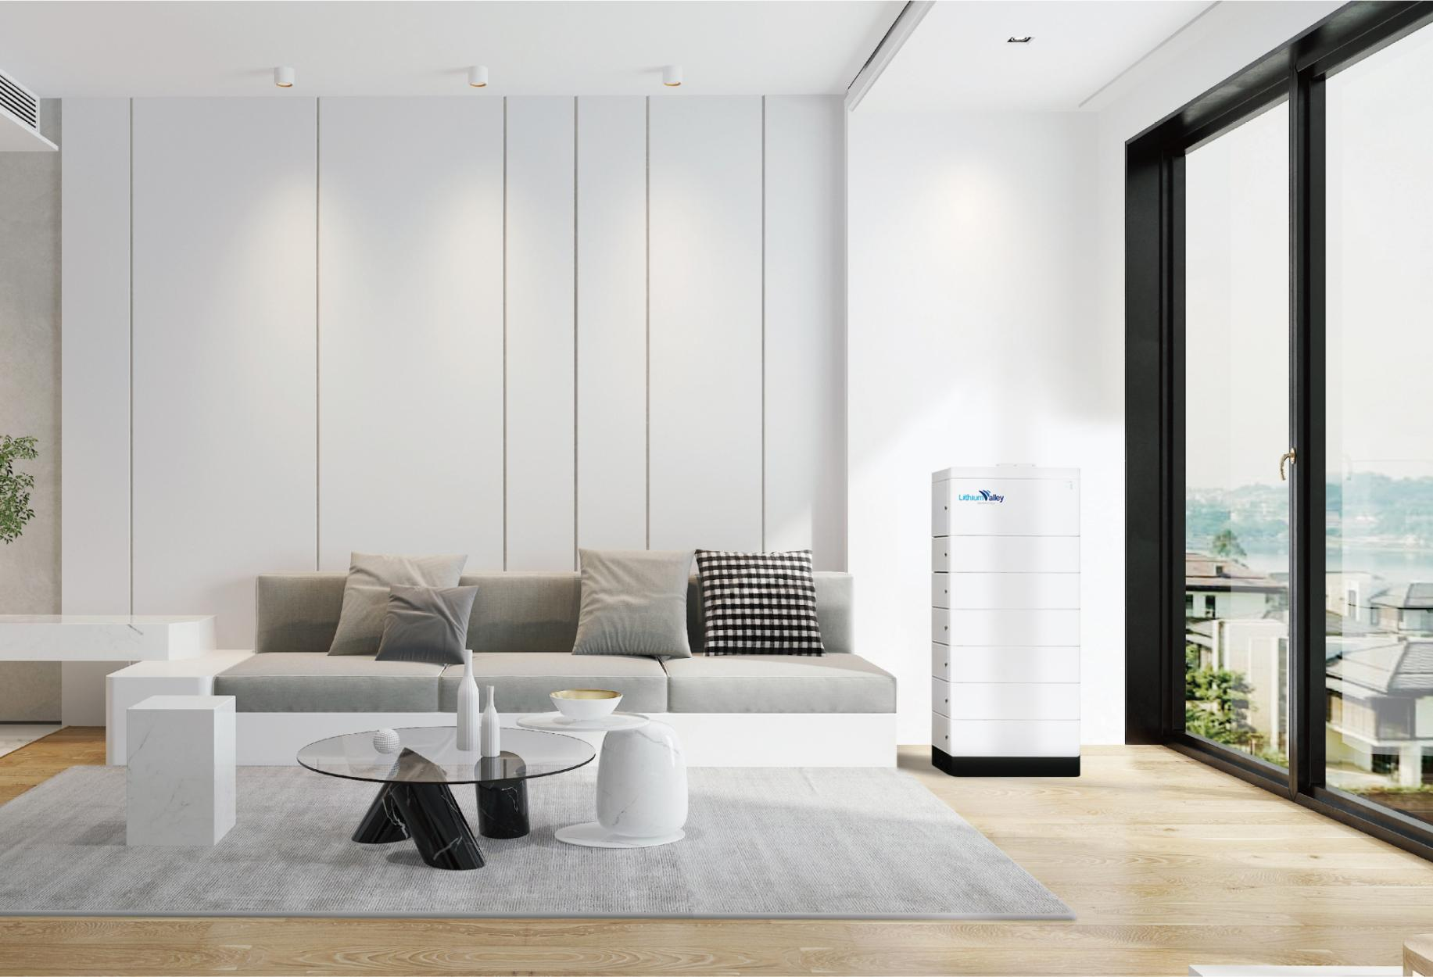

**LV-BST-H2.56Aa**

**Household Energy Storage**

**Capacity**

**51.2V 50Ah Single module**

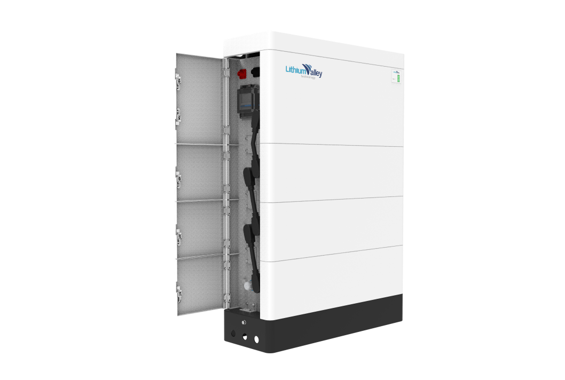

Smart Household Energy Storage System

* High-voltage LiFePO4 battery solution, Single module is 51.2V 50Ah 2.56kWh.
* 3 to 10 layers recommended.
* Inverter you need to choose 380V 3phase input and output, common is 8-15KW inverter.
* Cobalt Free Lithium Iron Phosphate (LFP) Battery: Maximum Safety, Life Cycle and Power.
* Applicable on grid or hybrid on and off-Grid solar energy storage system.
* Self-Consumption Optimization for Residential and Commercial Applications.
* Modular Design Simplifies Transport and Installation.



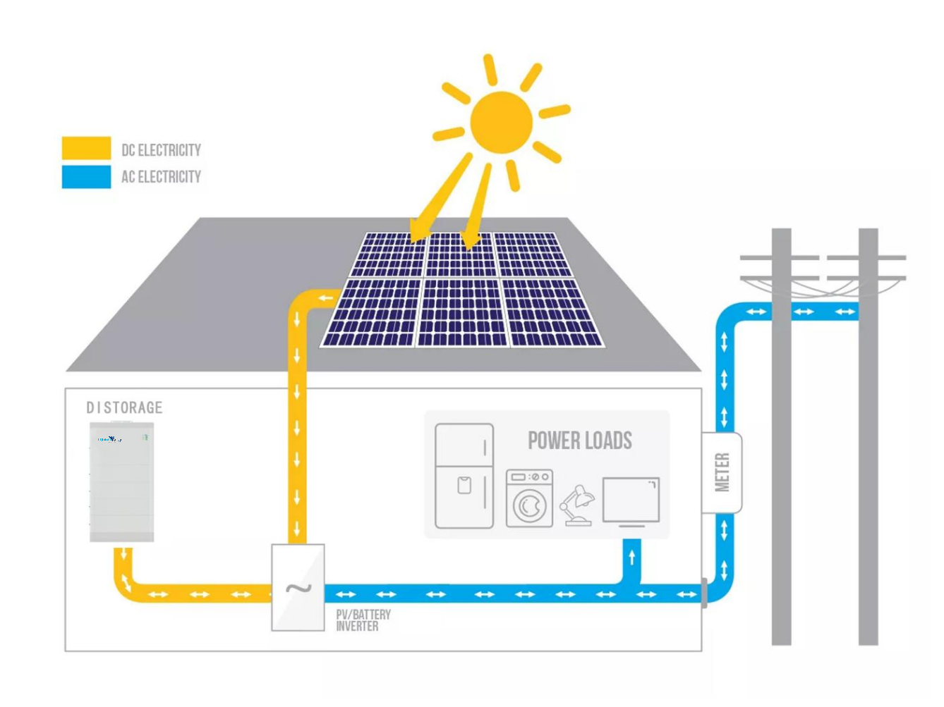

Field power

supply

Farm

Household



Application Scenarios

Nomadic area

Communication base station

Villa





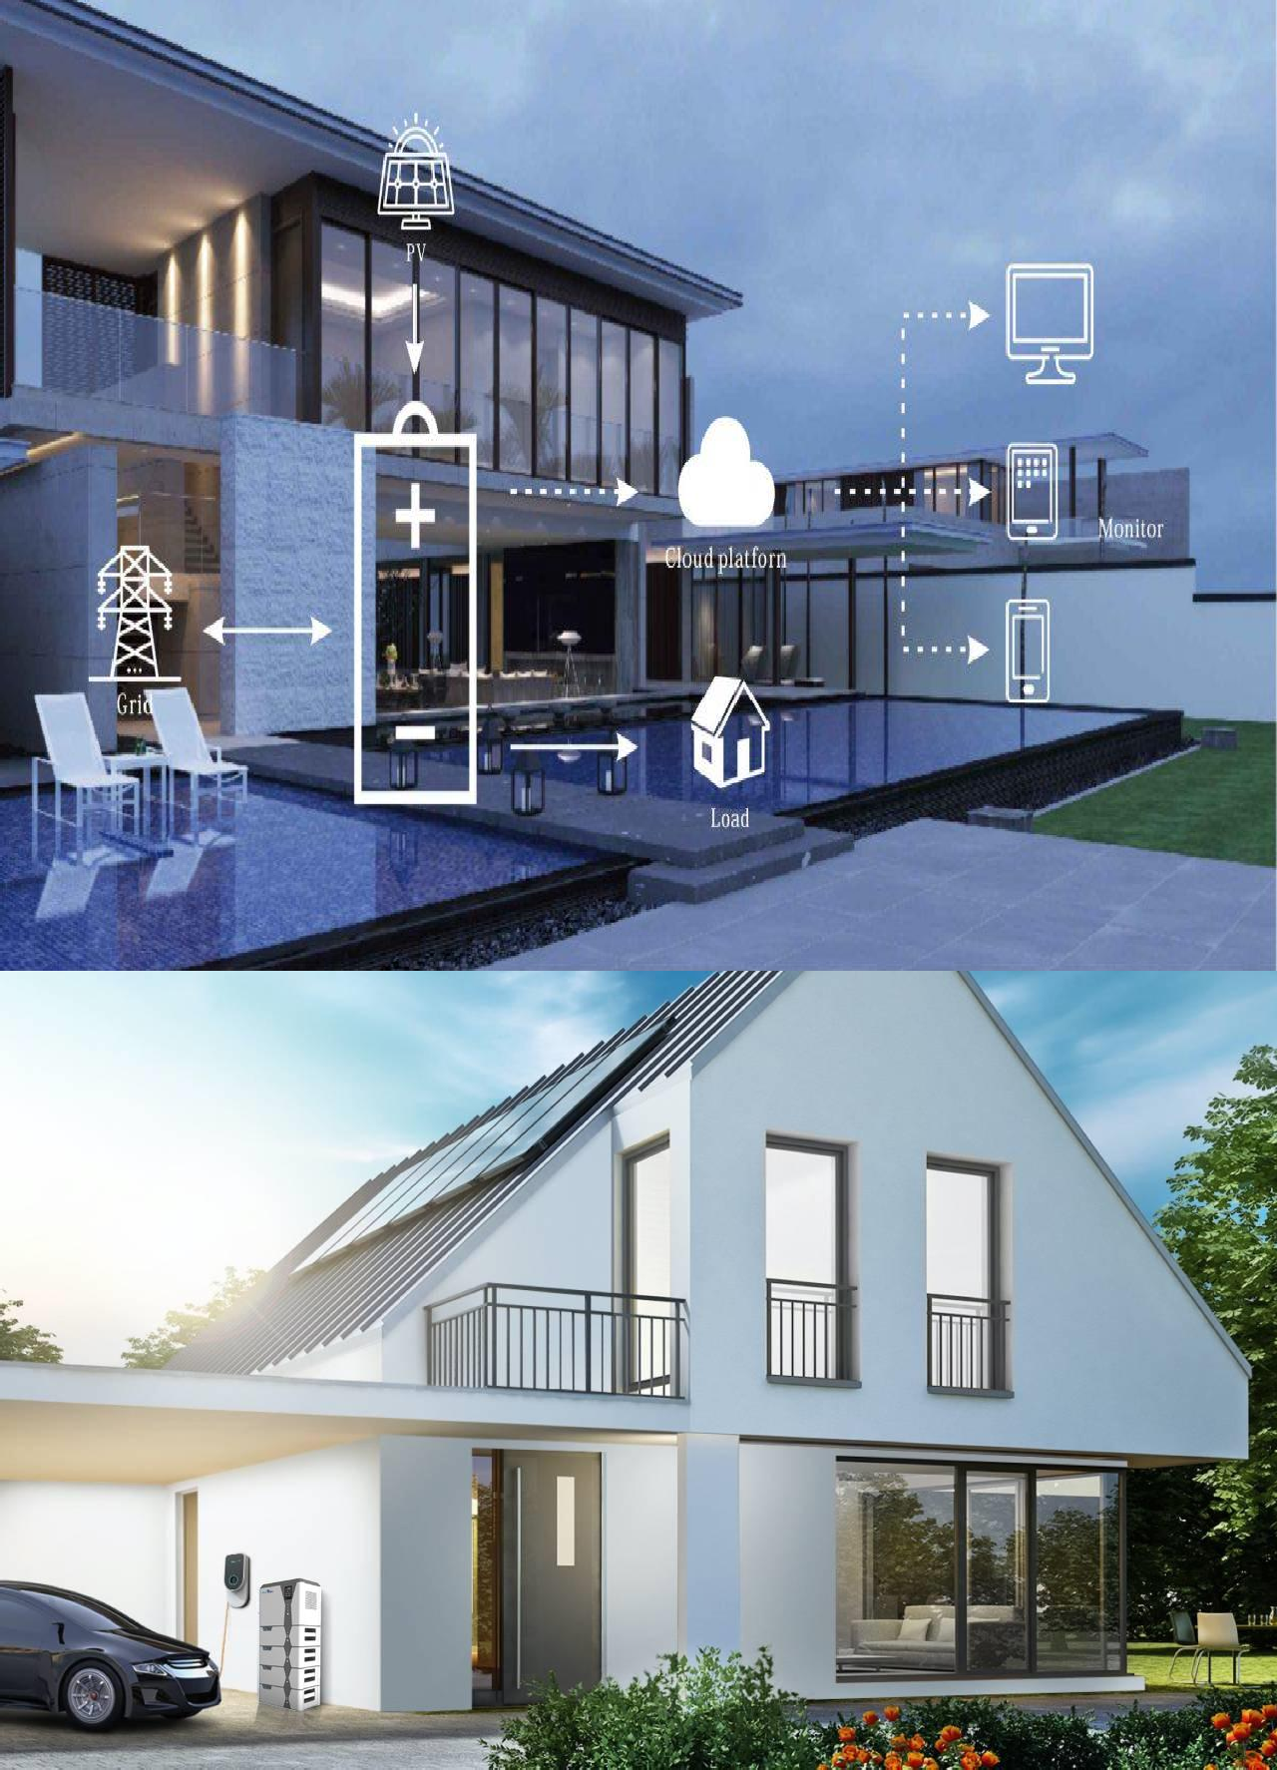

Advantages

* High Voltage
* High Capacity
* Scalable Design
* Integrated Design
* Efficient Performance
* Safe and Reliable
* Real-time Monitoring
* Intelligent BMS



|  |  |  |  |  |  |  |  |  |
| --- | --- | --- | --- | --- | --- | --- | --- | --- |
| **LV logoTechnical Specification** | | | | | | | | |
| Model | 153.6V  50Ah | 204.8V  50Ah | 256V  50Ah | 307.2V  50Ah | 358.4V  50Ah | 409.6V  50Ah | 460.8V  50Ah | 512V  50Ah |
| Number of layers | 3 layers | 4 layers | 5 layers | 6 layers | 7 layers | 8 layers | 9layers | 10layers |
| Picture | C:\Users\锂谷科技\Desktop\2.1.png2.1C:\Users\锂谷科技\Desktop\1.1.png1.1 |  | C:\Users\锂谷科技\Desktop\3.1.png3.1 | C:\Users\锂谷科技\Desktop\5.1.png5.1C:\Users\锂谷科技\Desktop\4.1.png4.1 |  | C:\Users\锂谷科技\Desktop\6.1.png6.1 | C:\Users\锂谷科技\Desktop\7.1.png7.1C:\Users\锂谷科技\Desktop\8.1.png8.1 |  |
| Energy | 7.68KWh | 10.24KWh | 12.8KWh | 15.36KWh | 17.92KWh | 20.48KWh | 23.04KWh | 25.6KWh |
| Operating Voltage Range | 129.6V～168.48V | 172.8V～224.64V | 216V～280.8V | 259.2V～336.96V | 302.4V～393.12V | 345.6～449.28V | 388.8V～505.44V | 432V～561.6V |
| Dimension (L*W*H) | 600*210*820 | 600*210*980 | 600*210*1140 | 600*210*1300 | 600*210*1460 | 600*210*1620 | 600*210*1780 | 600*210*1940 |
| Net Weight | 102.5 | 129 | 155.5 | 182 | 208.5 | 235 | 261.5 | 288 |
| Recommend charge current | | 10~25A | | | | | | |
| Max continue charge current | | 50A | | | | | | |



|  |  |
| --- | --- |
| Max continue discharge current | 50A |
| Peak current | 100A |
| Display | The information of Battery, such as SOC, battery voltage and so on |
| Communication | Support RS485 / CAN |
| Operating temperature | -20℃～55℃ |
| Environment | Indoor |
| Relative humidity | 5%～95% |
| Cooling | Natural convection |
| Cell technology | Lithium-iron phosphate (LiFePO4) |
| Life cycle | 6000 times @80%DOD |
| **Single module Technical Specification** | |
| Dimension (L*W*H) | High Voltage Box:600*210*250 Battery Box:600*210*160 |
| Battery module weight | 26.5kg |

